Determinant of a Matrix:
Consider a square matrix of order 3 say . Then despite of other methods, we have a quicker one.Just place 1st two columns adjacent to the determinant,
. Just note the directions of arrows, from left to right and right to left DIAGONALLY.
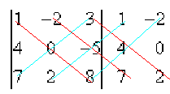
For red lines take positive signs and multiply the elements and then add for each individual. i.e
1(0)8+(-2)(-5)(7)+3(4)(2)=0+70+24=94
For Blue lines take negative signs and multiply the elements and then add for each individual. i.e
(-2)(4)(8)+1(-5)(2)+(3)(0)(7)=-64-10+0=-74
Finally subtract the blue results from reds to get the determinant of A i.e
Det(A)=|A|=94-(-74)=168.

Minor and Cofactors an Element of a Matrix:
First of all remember, determinant is calculated for whole matrixes while the Minors and Cofactors are for the individual elements of a matrix.
A "minor" is the determinant of the square matrix formed by deleting one row and one column from some larger square matrix. For example if you are asked to find the minor of a₂₂=0, then delete 2nd row and 2nd column i.e
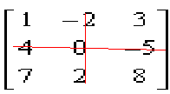. So we left with
whose determinant will give Minor of (a₂₂=0)=M₂₂=8-21=-13.
Similarly one additional step will give its Cofactor = (-1)²⁺²(-13)=1(-13)=-13

